2016/2017 Scavenger Hunt
Kicked off in Philadelphia

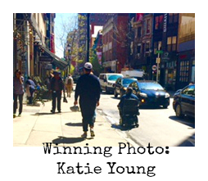
Thank you everyone who participated in the kickoff of ASIA’s Injury Prevention and Advocacy committees yearlong Scavenger Hunt.

We asked ASIA 2016 conference attendees to explore safety and accessibility on the streets of Philadelphia. Several photos were collected on smart phones and sent to asiaphotosa@societyhq.com.
Katie Young was announced as the winner and awarded a GoPro on the final day of the meeting.

The Scavenger Hunt in Philadelphia kicked off a yearlong campaign to help ASIA members recognize potential dangers and obstacles on roads and intersections. The goal is promote advocacy for safer options, improved accessibility, removal of barriers, and to identify related resources.
Take this mission to your area by identifying and photographing common dangers outside.
Send us your photos!
asiaphotos@societyhq.com
File requirements are as follows:
- File size- 5 MB. Photos will be blocked by the server if too large
- File type. Accepted image types are tiff, png, and jpg
- All submission emails MUST include the name of the submitter with contact information (email address and phone number)

This yearlong campaign will culminate in a session at the 2017 meeting in Albuquerque, NM
