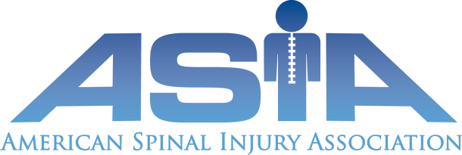

Date
{Company name}
{contact person}
{address}

Permission To Reprint
In consideration of publication with the appropriate credit line, American Spinal Injury Association “ASIA”) hereby gives {name/address}, its successors and assigns, and those acting under its permission or upon its authority, the right and permission to reproduce, publish, circulate, otherwise use the work described below. This permission also encompasses electronic distribution of the work. ASIA warrants that it owns all legal rights and copyrights to the work. ASIA further warrants that it has full authority to enter into this agreement.

Name of copyright holder: American Spinal Injury Association
Title of Work: {title of publication/use of chart}
The dermatome chart that is contained in the ASIA publication “International Standard for Neurological Classification of Spinal Cord Injury” may be freely copied but not changed in any way without prior permission from the American Spinal Injury Association.
Credit Line to appear as follows: “© 2011 American Spinal Injury Association. Reprinted with permission.”

Patricia Duncan
Executive Director

