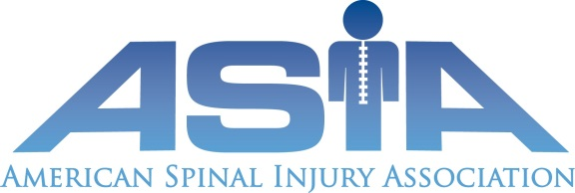

ASIA RESEARCH AND AWARDS COMMITTEE
APPLICATION FORM FOR THE CRAIG H. NEILSEN FOUNDATION ALLIED
HEALTH PROFESSIONAL RESEARCH AWARD OF ASIA

Please include the following information (maximum of five pages excluding references and letters of support, single spaced, 12 point font, Arial)
1. NAME, CONTACT INFORMATION AND INSTITUTIONAL AFFILATION OF
THE APPLICANT:
2. NAME, CONTACT INFORMATION AND INSTITUTIONAL AFFILIATION OF THE
MENTOR:
3. SUMMARY OF THE PROPOSED PROJECT:
Please include the following: a) Introduction and Background including rationale
and significance, b) Overall Objective(s), c) Specific Aim(s) and Hypotheses or
research question, and d) an overview of the Experimental Design/Methods.
4. BUDGET DESCRIPTION: Maximum award is $25,000.
Provide a brief narrative/outline of the proposed cost categories (personnel,
supplies, travel, and other) with a brief justification. Equipment requests are not
encouraged but are allowed, if sufficient justification is provided. Equipment costs, if
included, may not exceed 10% of the total award of $25,000. Indirect costs are not
encouraged, but are allowed up to10%. Salary support for the mentor is not allowed.
5. TWO LETTERS OF SUPPORT:
a) one from the mentor for the project to include a brief description of the mentor’s
involvement and mentoring plan, b) description of commitment from the applicant’s
facility to support the project in a successful manner.
Deadline for submission is: September 9, 2016
For additional information, contact the ASIA Executive Director, Patty Duncan at:
patty@asia-spinalinjury.org. Submissions should be made electronically to this email address.

